**CSA1443- Compiler Design for Intraprocedural Analysis**

**192321047 – KAUSHIK NARAYANAN.V**

**LEX PROGRAMS –(23 TO 25)**

**23. Validate Mobile Number**

**Aim:**To create a LEX program that verifies whether a given mobile number is valid based on a specific format (e.g., Indian mobil numbers starting with 7, 8, or 9 and having 10 digits).

**Code:**

%{

#include <stdio.h>

%}

%%

[789][0-9]{9} { printf("Valid mobile number: %s\n", yytext); }

.|\n { /* Ignore other characters */ }

%%

int main() {

yylex();

return 0;

}

int yywrap() {

return 1;

}

**Output:**

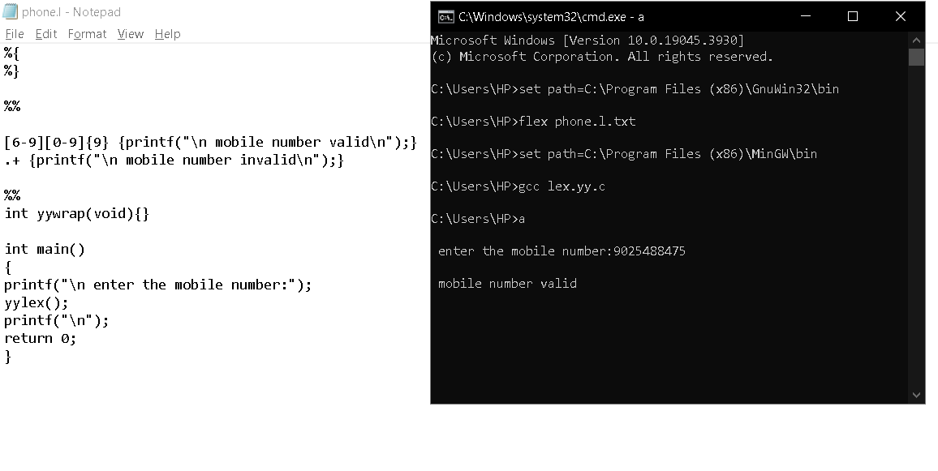

**24. Count the Number of Vowels**

**Aim:**To design a LEX program that scans an input sentence and counts the number of vowels (both uppercase and lowercase).

**Code:**

%{

#include <stdio.h>

int vowel_count = 0;

%}

%%

[aeiouAEIOU] { vowel_count++; }

.|\n { /* Ignore other characters */ }

%%

int main() {

yylex();

printf("Total number of vowels: %d\n", vowel_count);

return 0;

}

int yywrap() {

return 1;

}

**Ouput:**

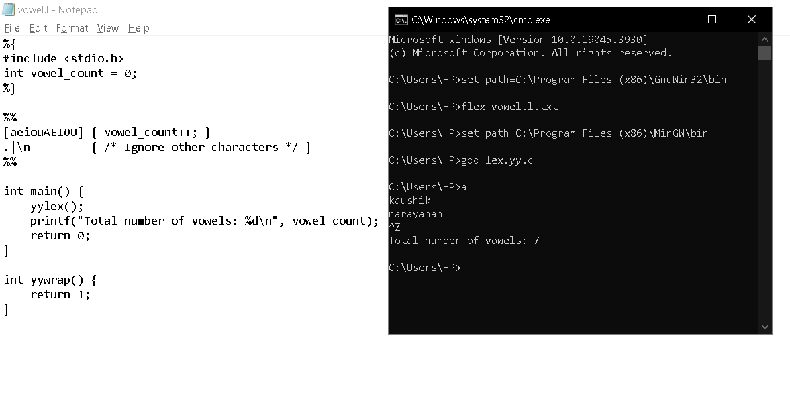

**25. Check if Input is a Digit**

**Aim:**To write a LEX program that determines whether the given input consists of digits and prints an appropriate message.

**Code:**

%{

#include <stdio.h>

%}

%%

[0-9]+ { printf("Input is a digit: %s\n", yytext); }

.|\n { /* Ignore other characters */ }

%%

int main() {

yylex();

return 0;

}

int yywrap() {

return 1;

}

**Output:**

